//design description

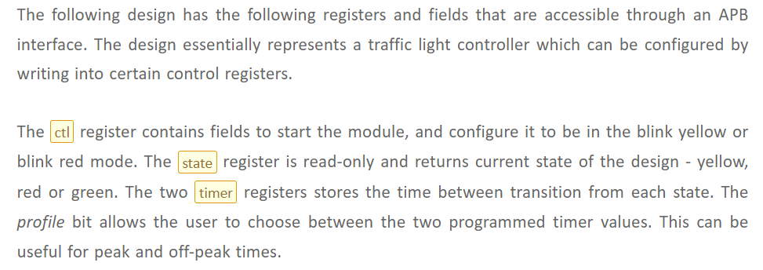

**Access type of register:-** Only stat reg is readonly(RO), ctl ,timer0 and timer1 registers are RW

**Design Code:-**

module traffic ( input pclk,

input presetn,

input [31:0] paddr,

input [31:0] pwdata,

input psel,

input pwrite,

input penable,

// Outputs

output [31:0] prdata);

reg [3:0] ctl_reg; // profile, blink_red, blink_yellow, mod_en RW

reg [1:0] stat_reg; // state[1:0]

reg [31:0] timer_0; // timer_g2y[31:20], timer_r2g[19:8], timer_y2r[7:0] RW

reg [31:0] timer_1; // timer_g2y[31:20], timer_r2g[19:8], timer_y2r[7:0] RW

reg [31:0] data_in;

reg [31:0] rdata_tmp;

// Set all registers to default values

always @ (posedge pclk) begin

if (!presetn) begin

data_in <= 0;

ctl_reg <= 0;

stat_reg <= 0;

timer_0 <= 32'hcafe_1234;

timer_1 <= 32'hface_5678;

end

end

// Capture write data

always @ (posedge pclk) begin

if (presetn & psel & penable)

if (pwrite)

case (paddr)

'h0 : ctl_reg <= pwdata;

'h4 : timer_0 <= pwdata;

'h8 : timer_1 <= pwdata;

'hc : stat_reg <= pwdata;

endcase

end

// Provide read data

always @ (penable) begin

if (psel & !pwrite)

case (paddr)

'h0 : rdata_tmp <= ctl_reg;

'h4 : rdata_tmp <= timer_0;

'h8 : rdata_tmp <= timer_1;

'hc : rdata_tmp <= stat_reg;

endcase

end

assign prdata = (psel & penable & !pwrite) ? rdata_tmp : 'hz;

endmodule